FINAL PROJECT REPORT
SMARTPHONE ADDICTION & DIGITAL WELL-BEING ANALYSIS
Power BI Data Analytics Project
Prepared from the supplied Power BI report screenshots and project template
Date: 22 September 2026

Executive Summary
This project presents an interactive Power BI analysis of smartphone usage, digital behaviour, addiction levels and selected digital well-being indicators. The report is built around a dataset covering 7,500 users and includes measures such as daily screen time, social-media hours, gaming hours, sleep hours, notifications per day, app opens per day, weekend screen time, work/study hours, stress level, age group, gender, academic/work-study impact and addiction level.
The supplied report contains five Power BI pages: KPI Cards, Visuals, Dashboard, Report 1 and Report 2. Across the pages, KPI cards, bar charts, line charts, a scatter plot, donut charts, a Sankey-style flow, and a Key Influencers visual are used to move from high-level measures to segmented analysis.
- The dataset contains 7,500 users; the average age shown is approximately 26.57 years.
- Average daily screen time is 7.50 hours, while average weekend screen time is 9.24 hours.
- Average social-media usage is 3.27 hours/day and average gaming usage is 2.01 hours/day.
- Average sleep duration is 6.74 hours and average notifications are 134.26 per day.
- The addiction-level distribution shown in the visuals is concentrated in the Moderate and Severe categories.
- Weekend screen time is visibly higher for Severe and Moderate addiction groups than for Mild and None groups.
- The report provides slicers/filters for addiction level, age group, gender and stress level, enabling segmented exploration.
Important interpretation note: these are descriptive patterns from the displayed Power BI aggregations. They should not be interpreted as proof that smartphone use causes a particular health, academic or psychological outcome.

Table of Contents
1. Introduction
1.1 Project Overview
1.2 Objectives
2. Project Initialization and Planning Phase
2.1 Define Problem Statement
2.2 Project Proposal (Proposed Solution)
2.3 Initial Project Planning
3. Data Collection and Preprocessing Phase
3.1 Data Collection Plan and Raw Data Sources Identified
3.2 Data Quality Report
3.3 Data Exploration and Preprocessing
4. Data Visualization
4.1 Framing Business Questions
4.2 Developing Visualizations
5. Dashboard
5.1 Dashboard Design Screenshot with Insights
6. Report
6.1 Report Design Screenshot with Insights
7. Performance Testing
7.1 Utilization of Data Filters
7.2 Number of Calculation Columns/Measures
7.3 Number of Visualizations
8. Conclusion/Observation
9. Future Scope
10. Appendix
10.1 Source Code (if any)
10.2 GitHub & Project Demo Link
References

1. Introduction

1.1 Project Overview
Smartphones are used for communication, entertainment, social networking, study/work and many other activities. A large usage dataset can be examined with business-intelligence techniques to understand how usage patterns differ across age groups, gender, stress levels and addiction categories. This project uses Microsoft Power BI to transform the supplied smartphone-usage data into an interactive analytical report.
The final Power BI solution emphasizes digital well-being indicators rather than a single usage metric. The dashboard combines screen time with social media, gaming, sleep, notifications, app-opening frequency, weekend usage, academic/work-study impact and addiction classifications.

1.2 Objectives
- To summarize smartphone-use behaviour using clear KPI cards.
- To compare daily and weekend screen time across addiction categories, genders and age groups.
- To examine relationships among screen time, sleep, gaming and social-media usage.
- To segment users using addiction level, age group, gender and stress level.
- To create an interactive Power BI dashboard and detailed report pages for exploratory analysis.
- To communicate findings in a form that can support further research and digital well-being interventions.

2. Project Initialization and Planning Phase

2.1 Define Problem Statement
The core problem is to convert raw smartphone-usage records into meaningful, interactive insights that show how usage intensity varies among different user segments. The analysis must make key indicators easy to understand while allowing users to drill into categories such as addiction level, age group, gender and stress level.

2.2 Project Proposal (Proposed Solution)
The proposed solution is a multi-page Power BI report. A KPI page provides headline measures; a visuals page contains exploratory charts; the dashboard provides a consolidated view; and two report pages provide more detailed segment-level analysis. Power BI filters and slicers are used to change the analytical context without changing the underlying dataset.

2.3 Initial Project Planning
Phase | Activities | Expected Output
Requirement analysis | Identify questions, KPIs and user segments | List of business questions and metrics
Data preparation | Inspect fields, types and categories; clean/standardize where required | Analysis-ready dataset
Exploratory analysis | Calculate averages/counts and compare segments | Initial patterns and hypotheses
Visualization | Select charts and KPI cards for each question | Power BI visual pages
Dashboard design | Arrange KPIs, charts and filters | Interactive dashboard
Validation | Check totals, labels, filters and visual consistency | Validated report
Documentation | Capture screenshots, insights and methodology | Final project report

3. Data Collection and Preprocessing Phase

3.1 Data Collection Plan and Raw Data Sources Identified
The analysis is based on the smartphone-usage dataset loaded into the supplied Power BI file. The screenshots expose the following fields or derived categories:
Field / Category | Role in Analysis
user_id | Unique user identifier / population count
gender | Gender-based segmentation
age | User age; used for average age
Age Group | Binned age segmentation, including 18–24, 25–34 and 35–44
daily_screen_time_hours | Primary daily screen-time measure
weekend_screen_time | Weekend usage comparison
social_media_hours | Social-media usage measure
gaming_hours | Gaming usage measure
sleep_hours | Sleep-duration measure
notifications_per_day | Notification frequency
app_opens_per_day | Application-opening frequency
work_study_hours | Work/study activity measure
academic_work_impact | Work/study impact category
stress_level | Low/Medium/High segmentation
addiction_level / addicted status | Addiction-related segmentation
smartphone usage / addiction indicator | Count/sum-based KPI shown in the report
The exact external origin, collection date and licensing details of the raw dataset are not visible in the supplied screenshots. Therefore, this report treats the PBIX dataset as the project data source and does not invent an external dataset attribution.

3.2 Data Quality Report
The visible report contains 7,500 user records in the main user count KPI. The screenshots demonstrate consistent use of categorical dimensions and numeric aggregations, but the raw table is not exposed. Consequently, some data-quality checks cannot be independently verified from screenshots alone.
Quality Check | Evidence Available | Assessment
Record count | Count of user_id = 7,500 | Visible and usable
Numeric aggregation | Average/sum aggregations displayed | Usable for descriptive analysis
Category labels | Addiction, age group, gender, stress and impact categories visible | Usable
Missing values | Raw rows not provided | Not independently verifiable
Duplicate user IDs | Raw rows not provided | Not independently verifiable
Outliers | Scatter plot provides visual screening | Some extreme values are visible; row-level validation not possible
Data types | Power BI fields are being aggregated correctly in visuals | Generally consistent in displayed report
A production version should additionally run explicit null-value, duplicate-key, range and outlier checks in Power Query or the source database.

3.3 Data Exploration and Preprocessing
- Age was summarized both as an average (26.57 years) and as age groups for comparative analysis.
- Usage variables were summarized with averages for daily behavioural measures and a sum for work/study hours.
- Categorical dimensions such as addiction level, stress level and academic/work-study impact were used for segmentation.
- Weekend screen time was separated from daily screen time to highlight differences in non-working/non-study periods.
- Visual-level, page-level and report-level filter areas were configured in Power BI, supporting interactive analysis.

4. Data Visualization

4.1 Framing Business Questions
Business Question | Purpose | Visual Approach
Q1 | What is the overall size and profile of the user population? | User count, average age and headline KPIs
Q2 | How much time do users spend on smartphones each day and on weekends? | Daily and weekend screen-time averages
Q3 | How does screen time vary by gender and age group? | Bar/column comparisons
Q4 | How is the user population distributed across addiction levels? | Addiction-level count charts
Q5 | How do addiction categories relate to weekend screen time? | Grouped bar chart
Q6 | How do social-media and gaming behaviours compare? | Comparative bar chart
Q7 | How does sleep vary by age group? | Line chart
Q8 | How are users distributed by stress and high/normal screen-use categories? | Donut charts and slicers
Q9 | How do work/study hours differ by academic/work impact? | Comparison bar chart
Q10 | Which segments can be explored interactively? | Slicers, Sankey-style flow and Key Influencers

4.2 Developing Visualizations
The visual design follows a top-down approach: KPI cards communicate the scale of the dataset, charts provide comparisons, and interactive report pages allow segmentation. Bar charts are used for category comparison, line charts for ordered age-group patterns, donut charts for composition, a scatter plot for screen-time versus sleep, a Sankey-style flow for multi-stage segmentation, and a Key Influencers visual for exploratory factor analysis.
The Power BI report uses a consistent layout within each page, with titles, labels and filter controls positioned so that the user can move from overall metrics to detailed patterns. Microsoft describes Power BI reports as interactive, multi-page documents built from visualizations, and its filter pane supports visual-, page- and report-level filtering. These capabilities align with the structure visible in the supplied project.

5. Dashboard

5.1 Dashboard Design Screenshot with Insights
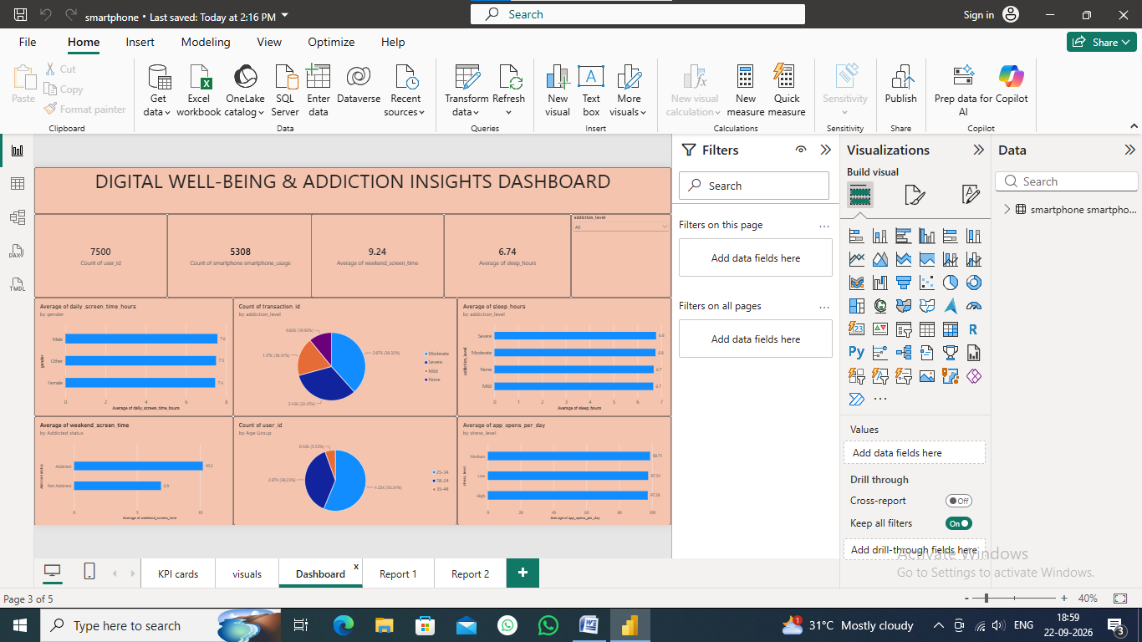
Figure 1. Digital Well-Being & Addiction Insights Dashboard (supplied Power BI screenshot).
Dashboard observations:
- The dashboard foregrounds 7,500 users, 5,308 on the displayed addiction-related KPI, average weekend screen time of 9.24 hours and average sleep of 6.74 hours.
- Daily screen time is approximately 7.6 hours for males, 7.5 for the Other category and 7.4 for females in the displayed gender comparison.
- The addiction-level count visual shows Moderate as the largest category, followed by Severe, Mild and None.
- Average sleep is clustered around 6.7–6.8 hours across the displayed addiction levels, indicating only small differences in the visible aggregation.
- Average weekend screen time is highest for the Severe and Moderate categories (about 10.4 and 10.1 hours) and lower for Mild (about 7.3) and None (about 6.2).
- The average app-opens-per-day visual is close to 97–98 across the displayed stress levels, showing relatively small differences compared with the much larger variation in screen time.
- The dashboard includes an addiction-level slicer, allowing the displayed charts to be narrowed to a chosen addiction category.
Interpretation: the dashboard suggests that addiction category is more visibly associated with differences in weekend screen time than with the small differences in average sleep shown on this page. This is a descriptive observation from aggregated values, not a causal conclusion.

6. Report

6.1 Report Design Screenshot with Insights
The project includes two detailed report pages. The first emphasizes screen-time behaviour, academic/work-study impact and age-group patterns; the second emphasizes gaming, sleep, stress and social-media behaviour.
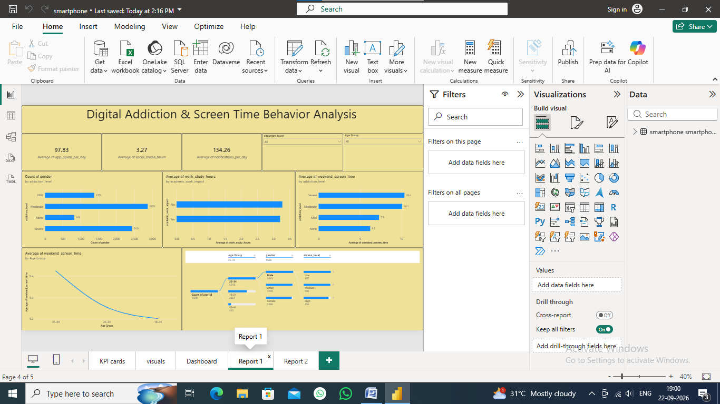
Figure 2. Report 1 – Digital Addiction & Screen Time Behavior Analysis.
- Average app opens per day = 97.83; average social-media hours = 3.27; average notifications per day = 134.26.
- Weekend screen time is approximately 10.4 hours for Severe, 10.1 for Moderate, 7.3 for Mild and 6.2 for None.
- The age-group line shows weekend screen time decreasing slightly from the 35–44 group to 25–34 and then 18–24 in the displayed aggregation.
- The work/study comparison shows only a small difference between the 'Yes' and 'No' academic/work impact groups in the displayed average.
- The flow visual demonstrates how age group can be followed into gender and stress-level segments, supporting multi-dimensional exploration.
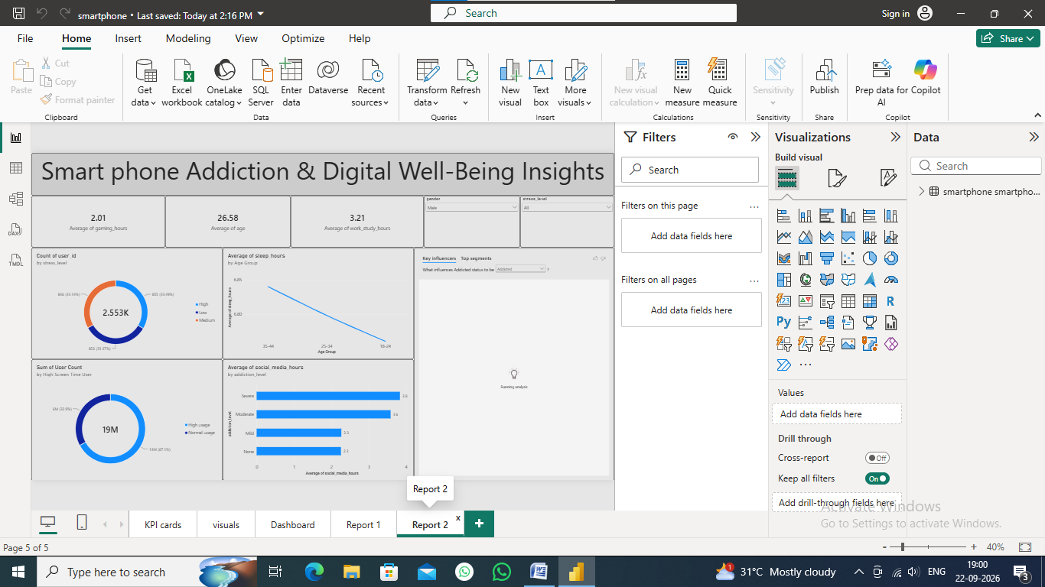
Figure 3. Report 2 – Smartphone Addiction & Digital Well-Being Insights.
- Average gaming time = 2.01 hours; average age = 26.58 years; average work/study hours = 3.21 in this filtered/report context.
- The stress-level donut contains 2.553K users in the displayed visual, with three stress categories represented.
- The high-screen-time composition visual shows approximately 32.9% high usage and 67.1% normal usage.
- Average social-media hours are highest in the Severe addiction category (about 3.8 hours), followed by Moderate (about 3.6), while Mild and None are about 2.3 hours.
- The sleep-by-age visual shows a small downward pattern across the displayed age groups.
- The Key Influencers visual is included for exploratory analysis, although the supplied screenshot was still displaying 'Running analysis', so no influencer result is claimed.

7. Performance Testing

7.1 Utilization of Data Filters
Page | Visible filter/slicer controls | Purpose
KPI Cards | Visual filter pane; Count of user_id selected | Controls/validates KPI context
Visuals | Page/report filter areas | Provides filtering infrastructure
Dashboard | Addiction level slicer | Focus all relevant dashboard visuals by addiction level
Report 1 | Addiction level; Age Group | Segment screen-time and behavioural analysis
Report 2 | Gender; Stress level | Segment digital well-being and stress analysis
Power BI supports filters at visual, page and report levels. The project uses these mechanisms alongside on-canvas slicers. This structure allows users to narrow the context while retaining the same underlying model.

7.2 No. of Calculation Columns/Measures
The screenshots visibly show 11 headline KPI values on the KPI Cards page: sum of addicted_label, count of user_id, average age, average daily screen time, average social-media hours, average gaming hours, average sleep hours, average notifications per day, average app opens per day, average weekend screen time, and a displayed sum of work/study hours. However, the screenshots do not expose the underlying Modeling pane or DAX definitions, so the exact number of custom calculated columns/measures cannot be independently verified.

7.3 No. of Visualization
Based on the visible report pages, there are approximately 41 visual elements: 10 KPI cards on the KPI page, 6 visuals on the Visuals page, 10 visible elements on the Dashboard page, 8 on Report 1 and 7 on Report 2. This count treats KPI cards as visual elements and is based on the supplied screenshots.
Page | Visible Visual Elements | Main Purpose
KPI Cards | 10 | Headline metrics
Visuals | 6 | Exploratory comparisons and relationships
Dashboard | 10 | Consolidated monitoring view
Report 1 | 8 | Screen time, addiction and academic/work patterns
Report 2 | 7 | Digital well-being, stress, sleep and social media

8. Conclusion/Observation
The Power BI project successfully converts smartphone-usage records into a multi-page interactive analytical report. The strongest visible patterns are the high overall screen-time level, the difference between weekday-style daily usage and weekend usage, the concentration of users in Moderate and Severe addiction categories, and the higher weekend screen-time values associated with those categories.
The report also shows that several well-being measures vary less than expected across some segments. For example, the displayed sleep averages remain close to 6.7–6.8 hours across addiction categories, while social-media hours show a clearer separation between Severe/Moderate and Mild/None groups.
Overall, the dashboard is useful for descriptive exploration because it combines population-level KPIs with segment-level comparisons and filters. The results should be treated as observational summaries. Without longitudinal or experimental data, the report cannot establish causation between smartphone usage and outcomes such as stress, sleep or academic impact.

9. Future Scope
- Connect the PBIX report to a regularly refreshed source so that trends can be monitored over time.
- Add a date dimension and time-series analysis if historical observations are available.
- Create explicit DAX measures with clear names, formatting and documentation instead of relying on implicit aggregations.
- Add correlation and statistical testing for screen time versus sleep, stress and academic/work impact.
- Introduce thresholds for high screen time and compare threshold groups consistently across age and gender.
- Improve accessibility with larger labels, higher contrast, descriptive alt text and a clear navigation menu.
- Complete the Key Influencers analysis after the visual finishes processing and document the resulting factors with appropriate caveats.
- Validate raw-data quality using automated null, duplicate, range and outlier tests in Power Query or the source system.
- Publish a documented data dictionary and add metadata for dataset origin, collection period and licensing.

10. Appendix

10.1 Source Code (if any)
No standalone source-code file is visible in the supplied project screenshots. The main implementation is a Power BI report (.pbix). The screenshots show Power BI visual configuration and aggregation-based analysis; the exact DAX expressions, if any, are not visible.

10.2 GitHub & Project Demo Link
GitHub repository: Not provided in the supplied material.
Project demo link: Not provided in the supplied material.
These fields should be replaced with the actual repository and published Power BI/portfolio links before submission.

Appendix A – KPI Summary from Supplied Screenshots
KPI | Displayed Value | Interpretation
User count | 7,500 | Number of users represented in the main KPI
Addiction-related KPI | 5,308 | Displayed sum of addicted_label; exact business definition should be confirmed from source data
Average age | 26.57 years | Average user age
Average daily screen time | 7.50 hours | Daily smartphone screen-time average
Average social-media time | 3.27 hours | Average social-media usage
Average gaming time | 2.01 hours | Average gaming usage
Average sleep | 6.74 hours | Average sleep duration
Average notifications | 134.26/day | Average daily notifications
Average app opens | 97.83/day | Average daily app openings
Average weekend screen time | 9.24 hours | Average weekend screen time
Sum of work/study hours | 24,318.15 | Displayed aggregate; not an average

Appendix B – Key Visual Insights
Area | Key observation
Addiction distribution | Moderate is the largest visible addiction-level group; Severe is the next largest.
Weekend usage | Severe and Moderate groups show much higher weekend screen time than Mild and None.
Gender screen time | Displayed daily screen-time averages are close across Male, Other and Female.
Age-group screen time | Daily screen-time averages are also close across the displayed age groups.
Social media | Severe and Moderate groups show higher average social-media hours than Mild and None.
Sleep | Average sleep is relatively stable across addiction categories in the displayed charts.
High/normal screen use | Report 2 shows about 32.9% high usage and 67.1% normal usage in its displayed composition.
Stress | Stress categories are available for segmentation and are shown in Report 2 and the Sankey-style analysis.

References
- Microsoft Learn – Power BI report and dashboard creation documentation: https://learn.microsoft.com/en-us/power-bi/create-reports/
- Microsoft Learn – Power BI reports overview: https://learn.microsoft.com/en-us/power-bi/create-reports/power-bi-reports-overview
- Microsoft Learn – Add a filter to a report in Power BI: https://learn.microsoft.com/en-us/power-bi/create-reports/power-bi-report-add-filter
- Microsoft Learn – Introduction to dashboards for Power BI designers: https://learn.microsoft.com/en-us/power-bi/create-reports/service-dashboards
- Microsoft Learn – Filter data in Power BI reports: https://learn.microsoft.com/en-us/power-bi/explore-reports/end-user-report-filter
- Project source: Supplied smartphone-usage Power BI (.pbix) project and screenshots

Appendix C – Supplied Power BI Screenshots
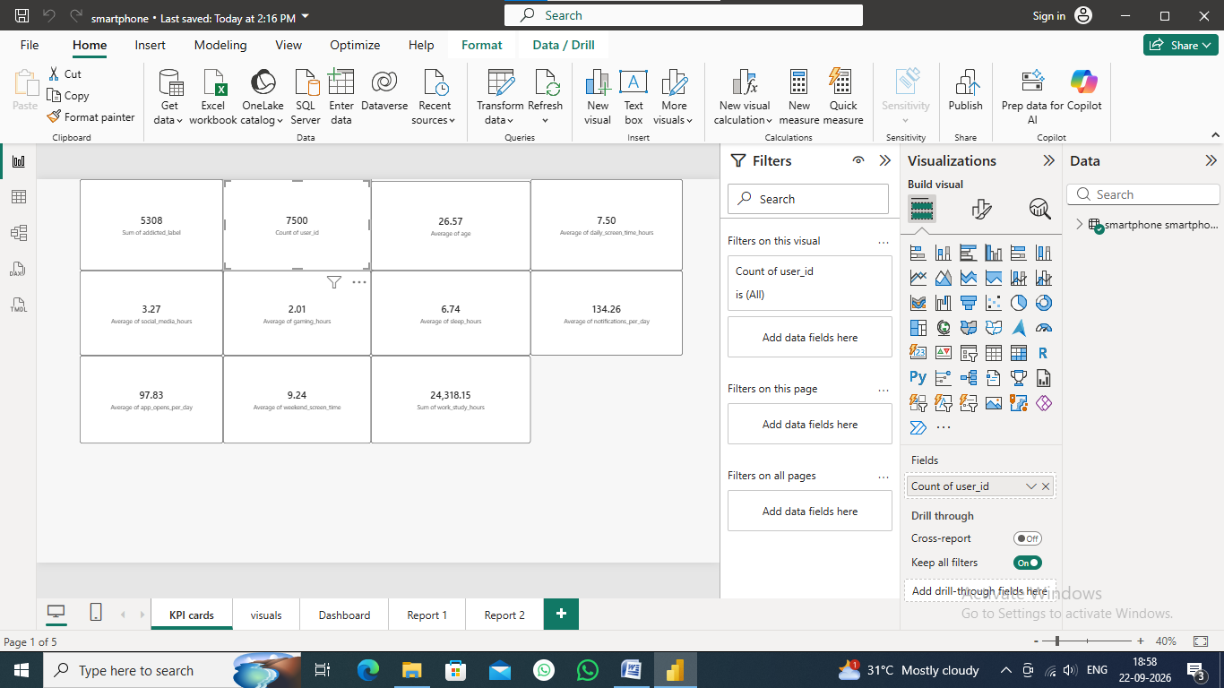
Figure C1. KPI Cards page.
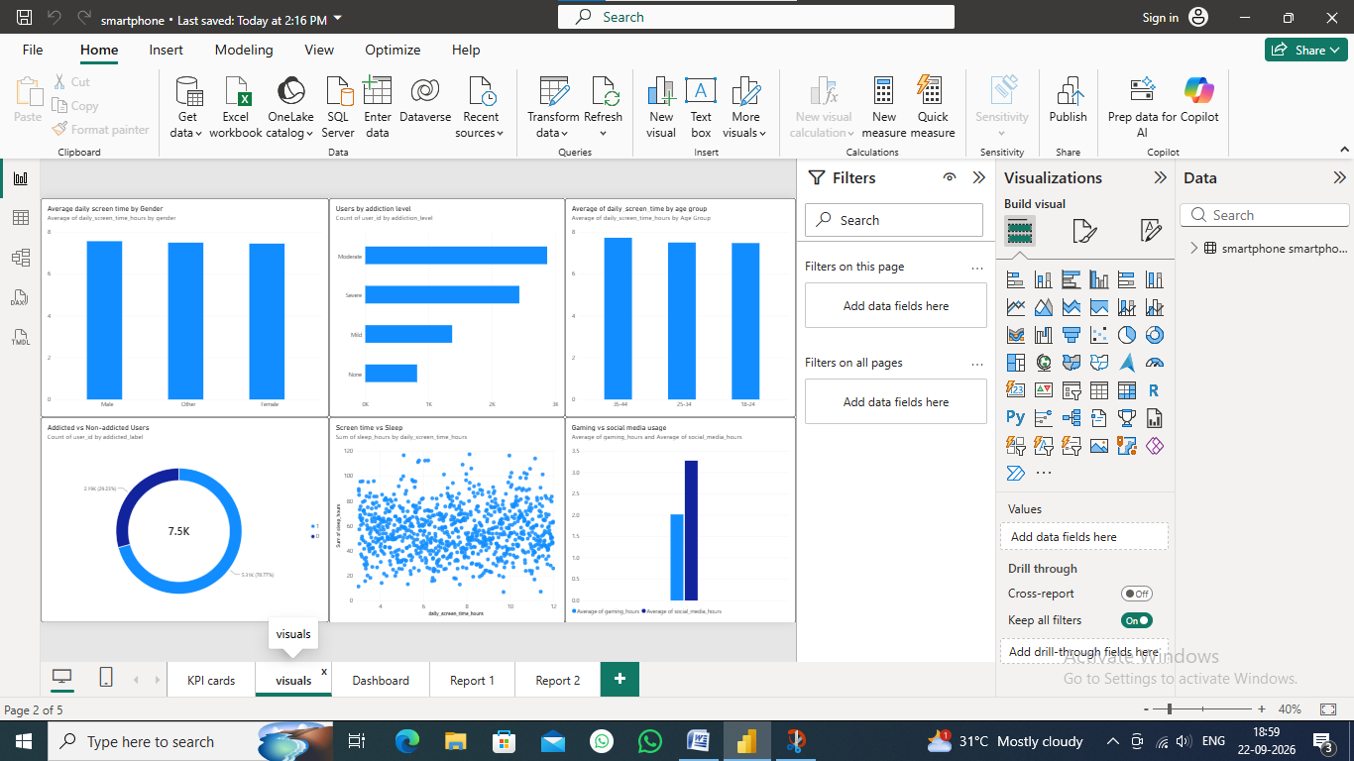
Figure C2. Visuals page.
Figure C3. Dashboard page.
Figure C4. Report 1 page.
Figure C5. Report 2 page.

